

**Green University of Bangladesh**

Department of Computer Science and Engineering

**Class Test-1**

**Course Code: CSE 202**

Course Name: **Object Oriented Programming Lab**

Date of submission: 01.11.2020

**Submitted By:**

Name: Md. Nur A Neouse

ID: 193002093

Department of CSE.

Green University Of Bangladesh

**Submitted To:**

Name: Feroza Naznin

Designation: Senior Lecturer

Department of CSE.

Green University Of Bangladesh

**Remarks:**

**Problem Name:**  **Java Program to Add Two Matrix Using Multi-dimensional Array of objects.**

**Objective:**

1. This program help us to know about the basics of JAVA.
2. We will learn to observe how loops and conditional statements work in an object oriented programming.

**Procedure:**

1. Start.
2. Open NetBeans and create a new class.
3. Declare 2 two dimensional array a and b.
4. Declare a two dimensional empty array sum.
5. Print sum as matrix .
6. End.

**Program Code (input):**

package addmatrix;

public class AddMatrix {

public static void main(String[] args) {

int rows = 2, columns = 3;

int[][] firstMatrix = { {2, 3, 4}, {5, 2, 3} };

int[][] secondMatrix = { {-4, 5, 3}, {5, 6, 3} };

// Adding Two matrices

int[][] sum = new int[rows][columns];

for(int i = 0; i < rows; i++) {

for (int j = 0; j < columns; j++) {

sum[i][j] = firstMatrix[i][j] + secondMatrix[i][j];

}

}

// Displaying the result

System.out.println("Sum of two matrices is: ");

for(int[] row : sum) {

for (int column : row) {

System.out.print(column + " ");

}

System.out.println();

}

}

}

**Output:**

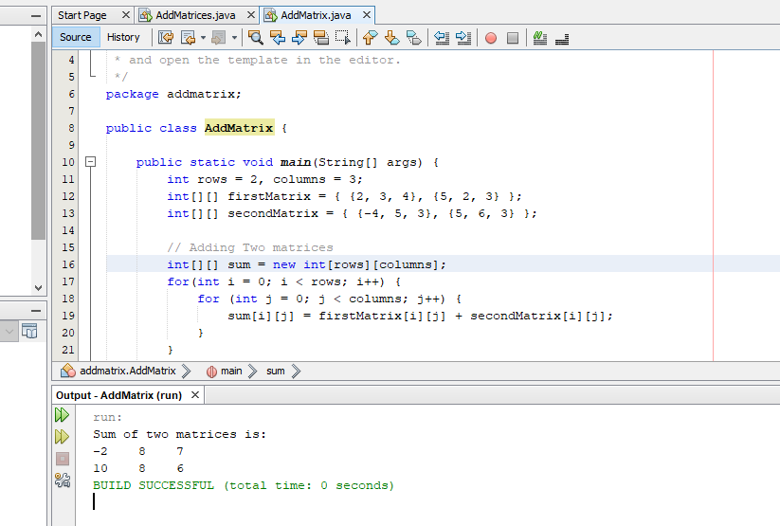

**Discussion:**

This program will help us to build up the basics foundation about object oriented

programming. We also learnt how to input and print something. In this program,

we used a for loop, a conditional statement, we checked which numbers are

even and calculated the sum of those numbers and printed the result.